GLOBAL PLATFORM LIBERIA
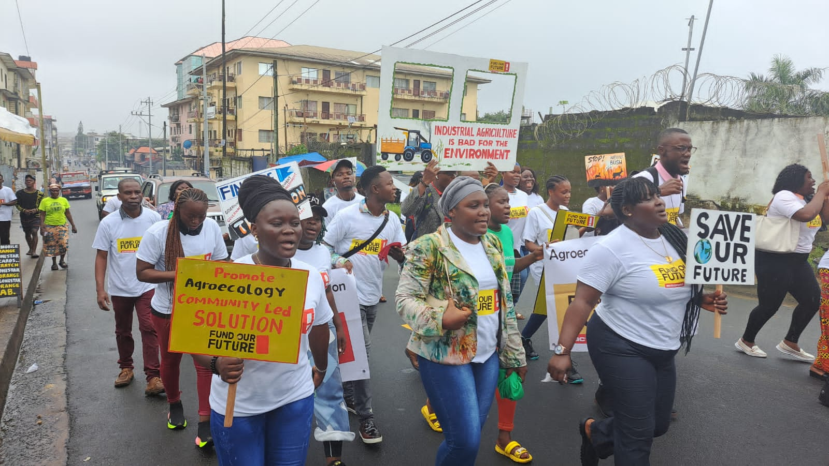
INTRODUCTION: WHY GLOBAL PLATFORMS?
ActionAid believes that youth and youth-led social movements hold tremendous potential for social change and offer valuable experience in confronting the political status quo and therefore play a key role in the fight for a more just and equal world. Youth are not only the leaders of tomorrow, but also drivers of change today. Young people are central to the development of society and an under-utilised resource of initiators and implementers of change. By harnessing this resource and fulfilling young people’s right to participate in their own development, we can significantly increase our impact and fulfil the promise of a more equal and just world for the present and coming generations of youth.
The Global Platforms are primarily youth hubs, meaning that the Global Platforms aim to create space for and provide strategic capacities towards the needs and demands of youth. The Global Platforms support, convene, and enable youth to create political change within and beyond AA programmes. It is a youth-leading space for building collective power. The GP is ActionAid’s (AA) network for youth led activism- a training hub for empowerment and activism, a worldwide network promoted by AA to engage active youth for social change. GP supports young people. Organizations and movements fighting for social justice. Achieving this dream goes beyond the physical space for engagement to integrating participatory learning principles with intentional leadership to drive the mission for which the platform was established. The Global Platforms offer a physical space that young leaders can fill with their own ideas, projects and campaigns. It is a space for innovation where new ways of organizing can be tested. We aim at expanding the outreach of the GP by establishing “satellite platforms” to reach out to the movements we wish to support. The Global Platforms is to be seen as social laboratories where innovative ideas on how to engage with youth can be piloted. This requires that the platform is working in close strategic alignment with ActionAid but is given operational flexibility to maximize innovation and to be responsive to new trends and emerging political agendas. With the growth and development of ActionAid’s global youth network, Activista, and an increased focus on youth mobilization in the AA international strategy, the Global Platforms became an important space for youth empowerment. The existing platforms started targeting national and regional youth and the Global Change training about campaign organising became the backbone of Activista empowerment strategy.
ActionAid Denmark is playing the role of managing the Global Platforms in partnership with ActionAid Liberia programmes.
Global Platform Liberia was launched in 2020 to enhance co-creation and knowledge sharing among young people in Liberia. The platform has since engaged young people directly through its training and hub activities while transforming youth-led organizations into a more forward-thinking establishment. GP Liberia head office is in Gbarnga, Bong County; space with the youth office at AA Liberia headquarter in Montserrado County; and two satellite platforms structures in Gbarpolu and Grand Gedeh.
OUR APPROACH
- Inspire – We inspire and engage people through participatory and action-oriented learning.
- Act – We support people to act on social injustice through organizing and creative activism.
- Connect – We connect people, organizations and movements across boarders

Youth Spaces We Support – We support three types of youth-led spaces:
- Spaces for participatory and action-oriented learning – The Global Platforms deliver participatory and action-oriented capacity building for young people, organisations and movements fighting for social justice. The focus is in three areas: CAMPAIGNING, RIGHTS and LEADERSHIP.
- Our portfolio includes a large catalogue of manuals, online toolkits and resources.
- Our capacity building is designed to actively engage people in the learning process and to support their learning in diverse ways before and after a face-to-face training.
- We design tailor-made capacity building or merely facilitation support - according to the needs of our partners and context.

- Spaces for creative activism and organizing for social justice – Through GP Youth Hubs we support youth-led spaces for young people to convene, strategize and act on social injustice. The GP Youth Hubs frequently organize or host network meetings, debates, documentary screenings, photo exhibitions, youth festivals and various campaign activities. The GP Youth Hubs are located at the existing Global Platforms, but in recent years we have created many new spaces for youth-led activism in collaboration with different partners. Examples are creative labs for music and artivism, hostels, mobile training hubs, digital communities, cafés, research centres, eco-gardens etc.

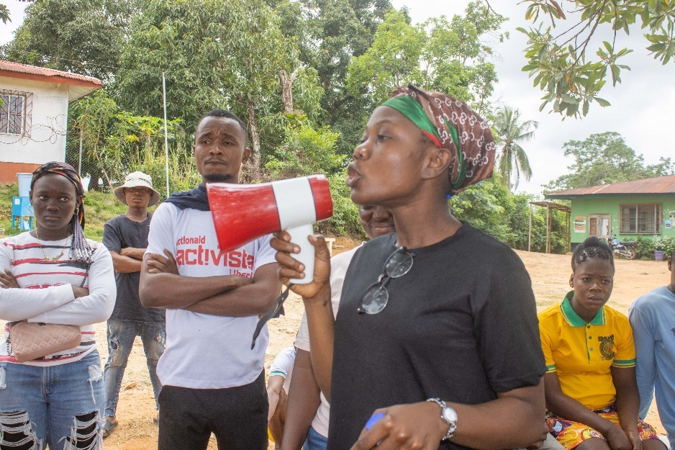
- Spaces for connecting, people organizations and movements – Social movements and networks nationally, regionally and globally are arising faster than ever before, but we often see them lose momentum after a short while. By connecting young people, networks and movements in communities across social and geographical borders we foster organizing, mutual learning, solidarity and sustained actions on emerging issues. We support movement building in various ways, organize convening of movement leaders, facilitate online communities for sharing knowledge and creating new alliances and campaigns with movements and networks

HOW WE WORK WITH LEARNING AND ACTIVISM
- Participatory Methods – Learn together
- Learning By Doing – Act, reflect, learn, apply.
- Feminist Lens – Challenge Patriarchy and inequality
- Political Empowerment – Analyze and change power structures
- Public Action Learning – Use society as a classroom
- Dream Big – Be creative, Seek Alternatives
All capacity building is guided by our learning development cycle:
- Context Analysis
- Decide
- Contextualize and Design
- Prepare and Deliver
- Evaluation and follow-up
- Impact Assessment
Learning Support:
- Coaching and Mentorship
- Follow-Up Activities after training
- Online Learning tools and Communities:
- Beautiful Trouble Module – Non-Violent Actions Manual
- Young People’s Leadership in Humanitarian Action Manual
THE CORE PRINCIPLES
The following core principles describe the essence of the Global Platform. To align with the new vision for our youth work in the federation, these principles were discussed, elaborated and decided upon.
Youth Hub
The Global Platforms are more than training institutions but are part of ActionAid’s effort to reach out to external youth and work with emancipation and action. The Global Platform offers a physical and intellectual space where youth and utilize their own ideas, projects and campaigns. A Global Platform is a space for innovation where new ways of organising are tested.
A Global Project
The Global Identity at the platforms is crucial and seen as a way to connect youth and create solidarity across the world, to learn from each other, to exchange ideas, and best practices, and be part of a bigger project and expand the global mind-set.
To reach this goal, the activities at the global platforms are both contextualized but also reach regionally and link up with similar trainings in other parts of the world. Currently in operation, AA’s international Training of Trainers cultivates the global mind-set and offers trainings where trainers meet and discuss how they can collaborate through a certain number of international/regional trainings in the yearly training.
Training principles
The Global Platform trainings are participatory and action-based trainings. We constantly innovate our training methods, to ensure high levels of engagement and concrete actions for sustainable change. All our trainings are based on our 6 training principles inspired from ActionAid’s Reflection-Action methodology holding political empowerment, public action learning, peer-to-peer learning and innovation in the core of our trainings. We believe these are the ingredients required for trainings that aim to develop people as active, global citizens.
Monitoring and evaluation
We need to be accountable in our own work. Furthermore, we need to continuously learn and develop from our own praxis and experience on what works and what does not work. Therefore, all trainings need to be evaluated according to the evaluation framework outlined in the 6 Steps – from data collection, through satisfaction and learning evaluation to evaluation of changes in behaviour and impact. We have developed a global system of monitoring and evaluation. The Global Platforms therefore need to conduct evaluations according to the overall evaluation framework. Simple systems and procedures have already been developed and implemented, and data can be used for strategic reporting, learning, training development and marketing.

Training quality
All new trainings will be developed through our “6 Step Pathway for Training Development”. The document points out the minimum steps and standards, which all Global Platform and trainers must follow when developing, planning, delivering and evaluating trainings. AADK has a global library of training manuals approved by the international training quality unit available for all trainers. All training manuals must be contextualised or designed specifically for the local context.
All Global Platform trainers will participate in a local TOT within the first three months of their contract or engagement (for volunteers). We will work with a certification system where our trainers can be certified after having participated in minimum two TOTs, an introduction and an advanced TOT, developed a specific number of trainings and conducted two weeks of training. GP Liberia also has a Learning Officer (LO), who has the responsibility to regularly share knowledge and develop the capacity of trainers through continuous workshops and feedback.
People we work with
The Global Platforms target young people ages 16-35 who have a potential to drive change. We work with marginalised youth from rural and urban settings and middleclass youth acting in solidarity with marginalised youth.
Staff
The Global Platform staff are critical, ambitious and energetic youth, making them the best ambassadors for other youth. The trainers at the Global Platforms should have different backgrounds, e.g., activists, facilitators, be from different counties, include at least one experienced trainer, and the manager should have international experience. All staff members should have a global mind-set.
Venue and location
We should always aim to be in a venue where the young people we work with feel welcome and free explore. We strive to find locations that are geographically accessible for the youth we work with.
- GP Liberia Head Office – Gbarnga, Bong County.
- GP National Level Office – AAL Head Office, Montserrado County.
- GP Hubs– Gbarpolu and Grand Gedeh Counties
1. COMMON VISION FOR THE PLATFORM
1.1 How do Global Platform Liberia contribute to AAI goals?
Global Platforms make a fundamental contribution to achieving the goals of ActionAid Internation “Action for Global Justice in a Volatile World” strategy.
1.2 How do the Global Platforms contribute to AA country goals?
It contributes to ActionAid Liberia Country Program Strategy “Action for Rights and Social Justice”. It is to be ensured that the Global Platform is an integral part of every newly developed Country Strategy Paper. It directly contributes to all three priorities areas which include:
- Priority Area One: Address Structural and systemic Gender Based Violence against Women, girls and other marginalized groups.
- Priority Area 2: Promote democratic governance and accountability through inclusive and active civic participation led by women to ensure access to gender-responsive public services and realization of community healthcare delivery, and health system strengthening.
- Priority Area 3: Build resilience of communities to adapt and mitigate the impact of climate change and disasters through climate just practices of natural resource governance, agroecology and sustainable livelihoods.

